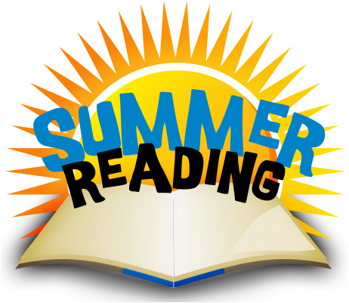
PROGRAMME 23-24

INFORMATION SHEET

To help stop ‘the summer reading slide’ and continue to utilise the library books while the school is closed we are running a Summer Reading Programme.
Details:
- Your child/children must not have any outstanding books.

- You may borrow up to eight books.

- You need to find a safe place in your house to keep them. You will be given a bag to help keep them together.

- You (child and parent/caregiver) sign a contract to promise to look after the books and return by the end of the first week of Term One, 2024.

- The library will be open extended hours before and after school so you can accompany your child/ren to share in book selection, contacts will be available to sign. Children can also go in class time in arrangement with their teacher (as long as they have a signed form)

- The library will be open:-
Monday 11th December 8:30am – 4:30pm
Tuesday 12th December 8:30am – 5:00pm
Wednesday 13th December 8:30am – 4:30pm
Thursday 14th December 8:30am – 5:00pm

Any queries please contact Emma Crossley on phone 233-1339 or email library@paremata.school.nz

