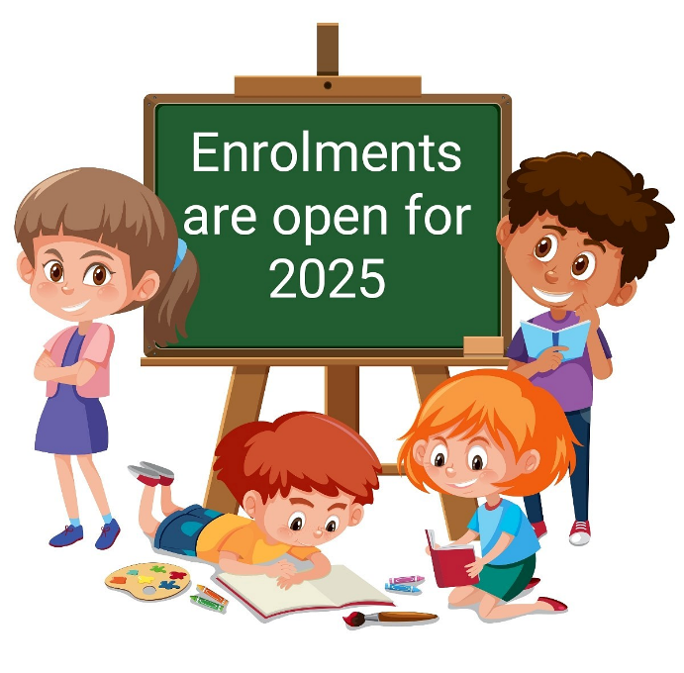

Applications are invited from parents who wish to enrol "out of zone" students at different levels at Paremata School for 2025. Enrolment at our school is governed by an enrolment school scheme.

Applications are to be made on the official enrolment form which is available from the school office. Please email office@paremata.school.nz or phone 233 1339 for more information.