New Pedagogies
for
Deep Learning (NPDL)

A Global Partnership

Purpose: To foster deep learning so that all learners contribute to the common good, address global challenges and flourish in a complex world.

Why Deep Learning?

The explicit aim of deep learning is to go beyond the mastery of existing content knowledge. Six deep learning competencies define what it means to be a deep learner. Deep learning experiences are engaging, relevant, authentic and build the 6 Deep Learning Competencies. Technology has unleashed learning, and the potential for students to apply knowledge in the world outside of school is accelerating. New pedagogies leverage all of this in the formal learning process.

Teaching shifts from focusing on covering all required content to focusing on the learning process, developing students’ ability to lead their own learning and to do things with their learning. Teachers are partners with students in deep learning tasks characterised by exploration, connectedness and broader, real-world purposes.

Learning outcomes are measured in terms of students’

- Capacities to build new knowledge and to lead their own learning effectively
- Proactive dispositions and their abilities to persevere through challenges, and
- The development of citizens who are life-long learners.

“The new pedagogies require students to create new knowledge and connect it to the world by using the power of digital tools.”

Deep learning tasks - “... harness the power of the new learning partnerships to engage students in practicing the process of deep learning through discovering and mastering existing knowledge and then creating and using new knowledge in the world.

Deep learning tasks are energised by the notion of ‘learning leadership’, in which students are expected to become leaders of their own learning, able to define and pursue their own learning goals using the resource, tools and connections that digital access enables” p.21.

Fullan, M. & Langworthy, M. (2014) A Rich Seam: How New Pedagogies Find Deep Learning, London: Pearson.

New Pedagogies for Deep Learning
How the elements interrelate.
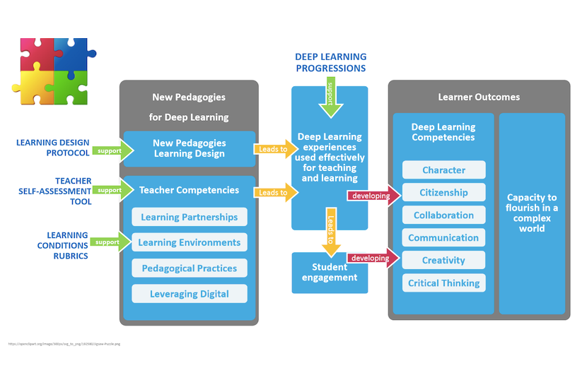
The diagram above shows the learning outcomes, the Deep Learning Competencies or the 6 Cs, we aim to develop in our students. We do this by designing deep learning experiences which will excite and engage them. The Collaborative Inquiry Cycle and the Learning Design Protocol help teachers to design, implement and measure the impact of deep learning experiences, while the four pillars of the Learning Conditions support teachers to consider ways to deepen learning.
Teachers assess their own Deep Learning teaching capability, using the Teacher Self-Assessment tool and moderate their Deep Learning designs in teams and across the school to develop understanding of Deep Learning.

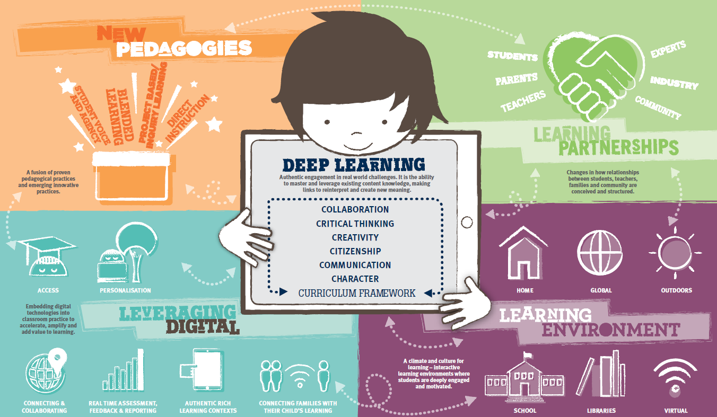
The New Pedagogies

These four elements “mobilize deep learning and combine to form the new pedagogies.”
NPDL Global Report p.19.

Pedagogical Practices –  - Student voice and agency  - Blended learning  - Project based / Inquiry learning  - Direct instruction | Learning Partnerships –  - Students  - Teachers  - Parents  - Community  - Industry  - Experts
Leveraging Digital –  - Personalisation  - Connecting & Collaborating  - Real time assessment, feedback & reporting  - Authentic rich learning contexts  - Accessible flexible learning | Learning Environments –  - Schools  - Home  - Global  - Outdoors  - Libraries  - Virtual

In deep learning tasks, it is the interaction of each quadrant which helps to deepen the learning for our students.

The Deep Learning Competencies
The 6 Cs
CREATIVITY  Having an ‘entrepreneurial eye’ for economic and social opportunities, asking the right inquiry questions to generate novel ideas, and leadership to pursue those ideas and turn them into action | CRITICAL THINKING  Critically evaluating information and arguments, seeing patterns and connections, constructing meaningful knowledge, and applying it in the real world.
COMMUNICATION  Communicating effectively with a variety of styles, modes, and tools (including digital tools), tailored for a range of audiences | CHARACTER  Learning to deep learn, armed with the essential character traits of grit, tenacity, perseverance, and resilience; and the ability to make learning an integral part of living.
CITIZENSHIP  Thinking like global citizens, considering global issues based on a deep understanding of diverse values and worldviews, and with a genuine interest and ability to solve ambiguous and complex real‐world problems that impact human and environmental sustainability | COLLABORATION  Work interdependently and synergistically in teams with strong interpersonal and team‐related skills including effective management of team dynamics and challenges, making substantive decisions together, and learning from and contributing to the learning of others.

These are the competencies we intentionally plan to develop in our students so that they are equipped to thrive in society.

The Collaborative Inquiry Cycle
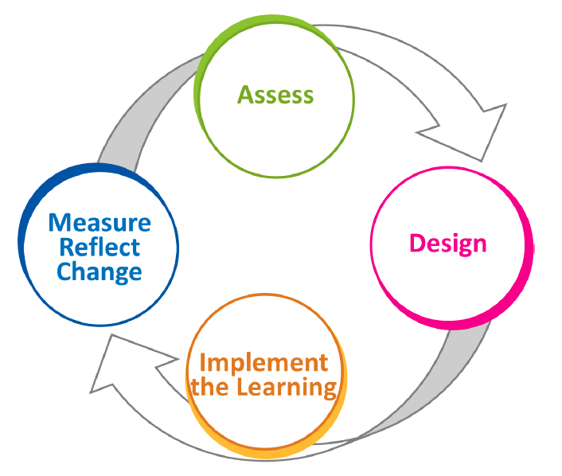
The Collaborative Cycle of Inquiry is used at many different levels of planning, measuring and assessing. It is used when planning deep learning tasks and when planning for team or whole school professional learning development.

ELEMENTS OF EFFECTIVE TEACHING PRACTICE FOR NEW PEDAGOGIES FOR DEEP LEARNING
ASSESSMENT | PLANNING | INSTRUCTIONAL PRACTICE | CLASSROOM ENVIRONMENT | ENGAGING LEARNERS WITH TEXT
- Assessment against the competencies will take place following each Deep Learning Task (DLT).  - Evidence for this can be gathered before, during and at the end of the DLT.  - Children will assess their own learning progress against the DLCs using the Student Friendly rubrics.  - Assessments will also be made against the curriculum objectives appropriate to the DLT.  - Students will help to design the criteria for success in the DLT against which they will evaluate their own learning progress.  - Assessment data will be stored on our Student Management System (Musac Edge)and Google Form document to monitor and track progress.  - Written reports will include information about students’ progress in developing the Deep learning Progressions. | - The Collaborative Inquiry Cycle will guide the design of DLTs.  - The Learning Design Protocol provides useful questions which guide learning design.  - Students will help to design the learning.  - Families will also be invited to contribute to the learning design.  - The learning design will include planning to develop elements of the 6 Cs as well as appropriate curriculum objectives.  - The learning design will indicate how the four elements of the new pedagogies are included.  - Learning contexts will be drawn from a wide range of possibilities: local, national or global events and issues.  - The relevance and interest to students will be the determining factor when selecting a deep learning focus.  - Planning is flexible, shaped by the direction of students’ interests. | - Students are partners with teachers in learning, learning design and assessment.  - The NPDL model is appropriate for any curriculum area and cross-curricula contexts.  - The teacher’s role is that of ‘activator’ of learning.  - Students co-create success criteria for learning.  - Students assess their progress in relation to the success criteria frequently during the DLT.  - Teachers will regularly conference with groups/students to check progress and provide guidance if and as required. | - Celebrations of learning will be displayed in classroom environments, including digitally e.g. blogs See Saw.  - Cues for learning will be displayed in classrooms.  - Respect will be shown for all learners and participants in DLTs.  - Classroom furniture and design/layout will maximise opportunities for learning partners to work collaboratively.  - Digital tools will be readily available to enable and accelerate deep learning. | - Contexts for deep learning experiences will be drawn from students’ interests, local, national or global events or issues.  - Students will co-create the learning design, success criteria and on-going assessment of their learning progress.

DEEP LEARNING
COMPETENCIES

Suite of Tools

The CollaThe Collaborati

