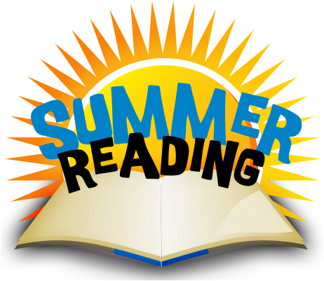
PROGRAMME 23-24

CONTRACT

………………………………………………………… has registered for the Paremata School Summer Reading Programme. He/she has taken home ………… books (maximum 8) and agrees to treat them with respect and return them to school by the end of the first week of Term 1, 2024. If not returned, the replacement cost will be charged.

Student signature: …………………………………………………… Date: ……………………………

Parent/ Caregiver agrees to support……………………………… with regards to the above.

Signed: ……………………………………………………………… Date: ……………………………

Emma Crossley (Librarian) * 233 1339 * library@paremata.school.nz

