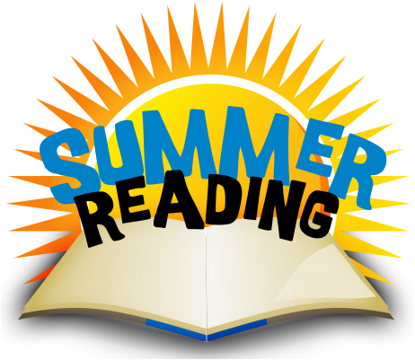

PROGRAMME 24-25

**CONTRACT**

**Child 1:**

First Name: ……………………………………………………Last Name: …………………………………………………………… has registered for the Paremata School Summer Reading Programme. He/she has taken home …………………… books (maximum 8) and agrees to treat them with care and respect and return them to school by the end of the first week of Term 1, 2025. If not returned, the replacement cost will be charged.

Student signature: …………………………………………………………………Date: ……………………………………………

**Child 2:**

First Name: ……………………………………………………Last Name: …………………………………………………………… has registered for the Paremata School Summer Reading Programme. He/she has taken home …………………… books (maximum 8) and agrees to treat them with care and respect and return them to school by the end of the first week of Term 1, 2025. If not returned, the replacement cost will be charged.

Student signature: …………………………………………………………………Date: ……………………………………………

**Parent/ Caregiver:**

I, …………………………………………………… agrees to support…………………………………………………………………… with regards to the above.

Parent/ Caregiver signature: ………………………………………………………… Date: …………………………………

Emma Crossley (Librarian) * 233 1339 * library@paremata.school.nz