
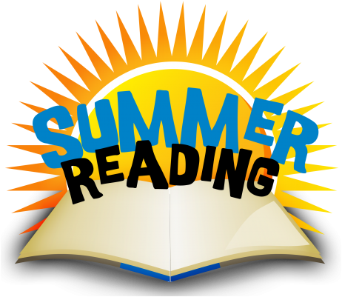
PROGRAMME 25-26

INFORMATION SHEET

To help stop ‘the summer reading slide’ and continue to utilise the library books while the school is closed we are running a Summer Reading Programme.
Details:
- Your child/children must not have any outstanding books.

- You (child and parent/caregiver) sign a contract to promise to look after the books and return by the end of the first week of Term One, 2026.

- You may borrow up to ten books.

- You need to find a safe place in your house to keep them. You will be given a bag to help keep them together.

- The library will be open extended hours before and after school so you can accompany your child/ren to share in book selection, contracts will be available to sign. Children can also go in class time in arrangement with their teacher (they need a form signed by a parent/caregiver)

- The library will be open:-
Tuesday 9th December 8:30am – 5:00pm
Wednesday 10th December 8:30am – 4:30pm
Thursday 11th December 8:30am – 5:00pm
Friday 12th December 8:30am – 4:30pm
Monday 15th December 8:30am – 4:30pm

Any queries please contact Emma Crossley on phone 233-1339 or email library@paremata.school.nz

SUMMER READING SLIDE

Studies show that the effect of the long summer break without reading books and listening to stories can make a significant difference to children’s reading achievements. This is known as the summer reading slide.

The summer reading slide is well documented by research – unless students read regularly during the break, they fall behind about three months in their reading achievement. The good news is that the latest research shows children who read at least four books over the summer maintain or even increase their skills.

Some facts:
- Kids, who read, succeed – the amount of time that students spend reading for fun is the key predictor of students’ academic achievement. (Gallik, 1999)
- It takes practice – reading, like playing a musical instrument, is not something that is mastered once and for all at a certain age. It is a skill that continues to improve through practice.
- Role models matter – students who see adults reading daily or weekly tend to read more and have higher reading scores than those who don’t.

Parents / caregivers can help:
- Make the time – establish quiet reading time after lunch or in the morning as a part of their daily summer routine.
- Become an expert – read up on reading! The following link has wonderful ideas.
Keeping your child or teen reading over summer
- Turn off the TV.
- Reward reading – it is okay to use an incentive e.g. sticker chart.
- Cook and read – as you prepare a meal together, have your child read the recipe to you.

